Template for Evidence(s)
UI GreenMetric Questionnaire

University : ...
Country : ...
Web Address : …

[5] Transportation (TR)
SAMPLE
[5.14] Program to limit or decrease the parking area on campus for the last 3 years (TR.6)

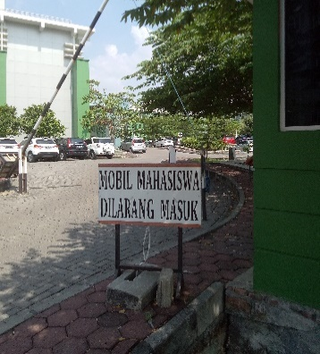 | 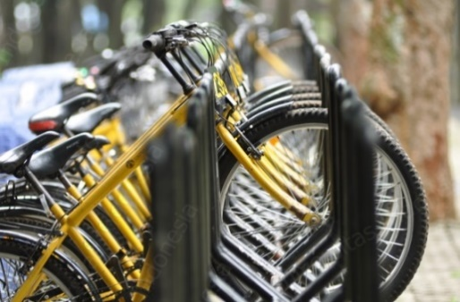
Limiting parking zone (Universitas Diponegoro, Indonesia) | Free Bicycle for rent (Universitas Indonesia, Indonesia)

Ride Share (Carpool) (Carleton University, Canada)
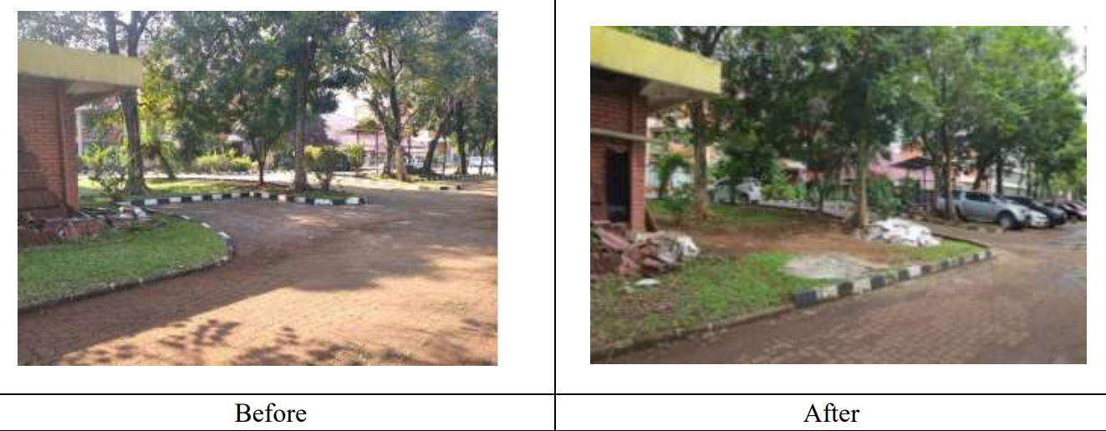

Description:
(Please describe the transportation initiatives to decrease private vehicles on campus and specify detail of data, e.g. campus bus, free bicycle, etc. The following is an example of the description. You can describe more related items if needed.)

- Limiting parking zone for students
- Free to rent bicycle on campus
- Ride share designed to encourage commuters to adopt healthy and sustainable transportation options. (Carpool)

Additional evidence link (i.e., for videos, more images, or other files that are not included in this file):
- https://carleton.ca/sustainability/campus/sustainable-transportation/carpool/

